Lab # 11
TRAINING A SINGLE LAYERED NEURAL NETWORK (PERCEPTRON) TO REPRESENT LOGIC FUNCTIONS AND , OR AND XOR IN PYTHON
Objective:
- Introduction to Neural Networks
- Implementing a neural Network to train a Perceptron to represent AND , OR and XOR functions
Lab Related Theory:
Introduction
Neural networks are a set of algorithms, modeled loosely after the human brain, that are designed to recognize patterns. They interpret sensory data through a kind of machine perception, labeling or clustering raw input. The patterns they recognize are numerical, contained in vectors, into which all real-world data, be it images, sound, text or time series, must be translated.
Neural networks help us cluster and classify. You can think of them as a clustering and classification layer on top of data you store and manage. They help to group unlabeled data according to similarities among the example inputs, and they classify data when they have a labeled dataset to train on. (To be more precise, neural networks extract features that are fed to other algorithms for clustering and classification; so you can think of deep neural networks as components of larger machine-learning applications involving algorithms for reinforcement learning, classification and regression.)
A few examples
Deep learning maps inputs to outputs. It finds correlations. It is known as a “universal approximate”, because it can learn to approximate the function f(x) = y between any input x and any output y, assuming they are related through correlation or causation at all. In the process of learning, a neural network finds the right f, or the correct manner of transforming x into y, whether that be f(x) = 3x + 12 or f(x) = 9x - 0.1. Here are a few examples of what deep learning can do.
Classification
All classification tasks depend upon labeled datasets; that is, humans must transfer their knowledge to the dataset in order for a neural to learn the correlation between labels and data. This is known as supervised learning.
- Detect faces, identify people in images, recognize facial expressions (angry, joyful)
- Identify objects in images (stop signs, pedestrians, lane markers…)
- Recognize gestures in video
- Detect voices, identify speakers, transcribe speech to text, recognize sentiment in voices
- Classify text as spam (in emails), or fraudulent (in insurance claims); recognize sentiment in text (customer feedback)
Any labels that humans can generate, any outcomes you care about and which correlate to data, can be used to train a neural network.
Clustering
Clustering or grouping is the detection of similarities. Deep learning does not require labels to detect similarities. Learning without labels is called unsupervised learning. Unlabeled data is the majority of data in the world. One law of machine learning is: the more data an algorithm can train on, the more accurate it will be. Therefore, unsupervised learning has the potential to produce highly accurate models.
- Search: Comparing documents, images or sounds to surface similar items.
- Anomaly detection: The flipside of detecting similarities is detecting anomalies, or unusual behavior. In many cases, unusual behavior correlates highly with things you want to detect and prevent, such as fraud.
Predictive analysis

With classification, deep learning is able to establish correlations between, say, pixels in an image and the name of a person. You might call this a static prediction. By the same token, exposed to enough of the right data, deep learning is able to establish correlations between present events and future events. The future event is like the label in a sense. Deep learning doesn’t necessarily care about time, or the fact that something hasn’t happened yet. Given a time series, deep learning may read a string of number and predict the number most likely to occur next.
- Hardware breakdowns (data centers, manufacturing, transport)
- Health breakdowns (strokes, heart attacks based on vital stats and data from wearables)
- Customer churn (predicting the likelihood that a customer will leave, based on web activity and metadata)
- Employee turnover (ditto, but for employees)
The better we can predict, the better we can prevent and pre-empt. As you can see, with neural networks, we’re moving towards a world of fewer surprises. Not zero surprises, just marginally fewer.
With that brief overview of deep learning use cases, let’s look at what neural nets are made of.
Neural network elements

Deep learning is the name we use for “stacked neural networks”; that is, networks composed of several layers.
The layers are made of nodes. A node is just a place where computation happens, loosely patterned on a neuron in the human brain, which fires when it encounters sufficient stimuli. A node combines input from the data with a set of coefficients, or weights, that either amplify or dampen that input, thereby assigning significance to inputs for the task the algorithm is trying to learn. (For example, which input is most helpful is classifying data without error?) These input-weight products are summed and the sum is passed through a node’s so-called activation function, to determine whether and to what extent that signal progresses further through the network to affect the ultimate outcome, say, an act of classification.
Here’s a diagram of what one node might look like.

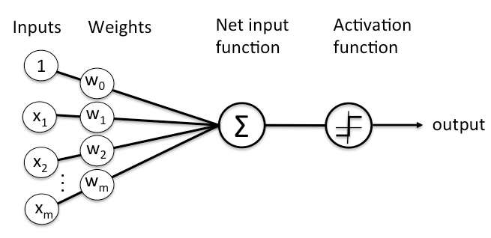

When a signal comes in, it gets multiplied by a weight value that is assigned to this particular input. That is, if a neuron has three inputs, then it has three weights that can be adjusted individually. The weights usually get adjusted during the learn phase.
After this the modified input signals are summed up. It is also possible to add additionally a so-called bias b to this sum. The bias is a value which can also be adjusted during the learn phase.
Finally, the actual output has to be determined. For this purpose an activation or step function Φ is used.
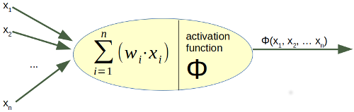

Implementing a neural network perceptron and trian it on logic ‘and’ function

Related description (and function)

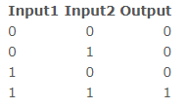

CODE:

- Import statement:

import numpy as np

- make a class named Perceptron

class Perceptron:

- Class functions

def __init__(self, input_length, weights=None):
if weights is None:
self.weights = np.ones(input_length) * 0.5
else:
self.weights = weights

@staticmethod
def unit_step_function(x):
if x > 0.5:
return 1
return 0

def __call__(self, in_data):
weighted_input = self.weights * in_data
weighted_sum = weighted_input.sum()
return Perceptron.unit_step_function(weighted_sum)

- Using class

p = Perceptron(2, np.array([0.5, 0.5]))
for x in [np.array([0, 0]), np.array([0, 1]),
np.array([1, 0]), np.array([1, 1])]:
y = p(np.array(x))
print(x, y)

References:
- https://www.python-course.eu/neural_networks.php
- https://deeplearning4j.org/neuralnet-overview

LAB EXERCISE

Q1. Write code of to implement Artificial Neural Network in Python for representing AND function as mentioned in the manual. Understand the code .Please also refer the details from website reference mentioned at the end of the manual.

Q2. Write a program to implement neural network in Python to represent OR function.

Q3. Write a program to implement neural network in Python to represent XOR function.
Learning Outcomes:
In this Lab we Implementing a neural Network to train a Perceptron to represent AND , OR and XOR functions

